**ASSIGNMENT DAY-04**

Less commands:

1.less f2

It can be used to read the contents of a text file one page.

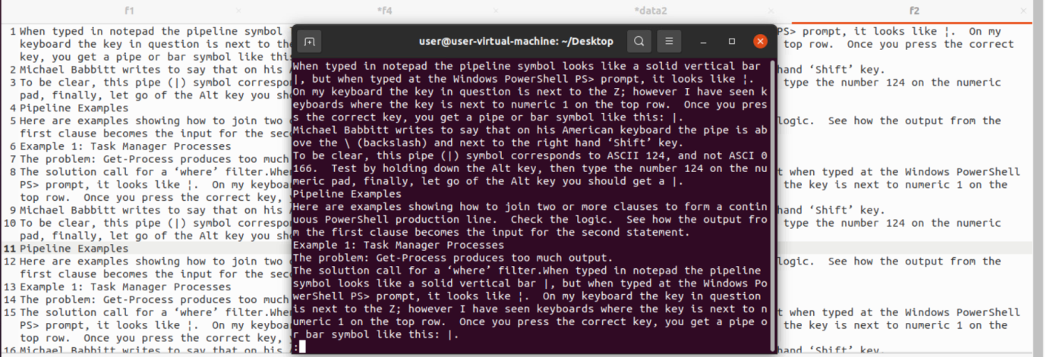

2.less –p ‘typed’ f2

The above command tells less to start at first occurrence of pattern “typed” in the file.

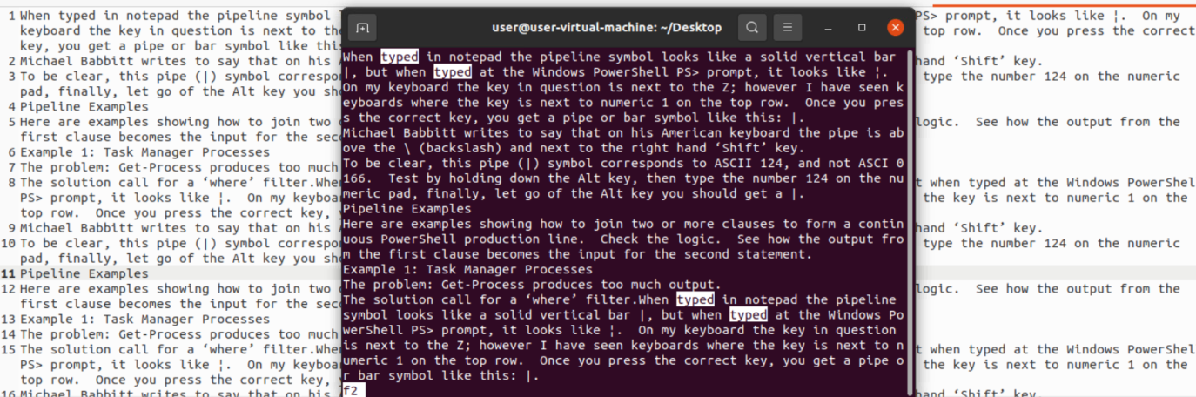

3.less –N f2

It displays the numbers of the paragraphs.

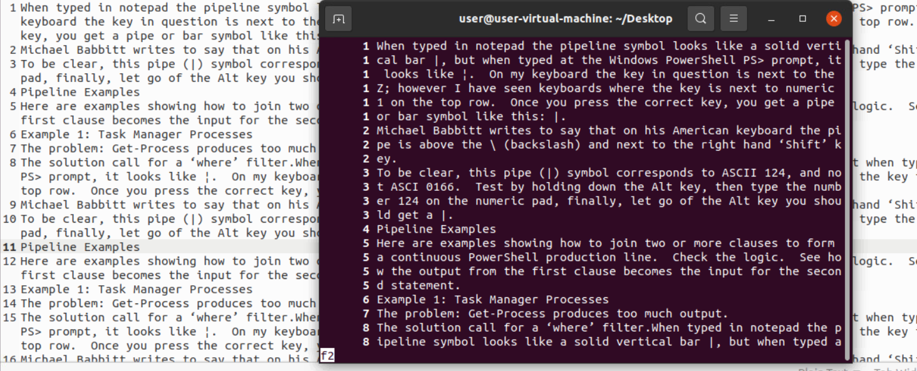

VIM command:

1.vim

It will open vim terminal.

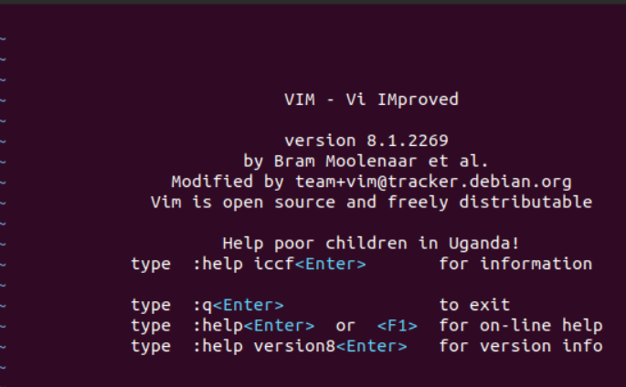

2. :!q

It is used to exit the vmi terminal

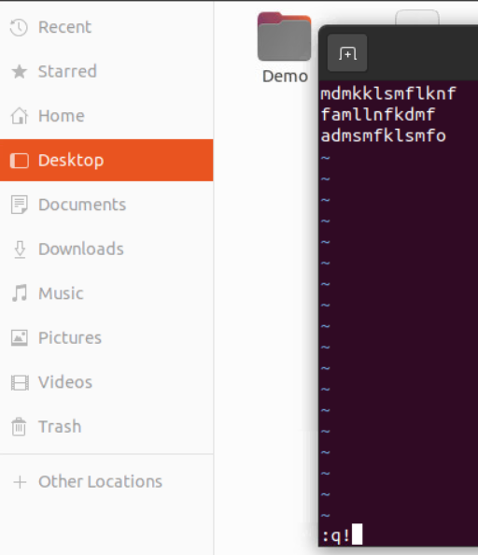

3. To exit without doing anything go into command mode by pressing the Esc key and type the following command.

:q

To exit from vim without saving changes type the following command in vim

:q!

To quit and save changes type the following command

:wq

4.vim f1

:r new

:w

Here it copies the data from new to f1 and saved it.

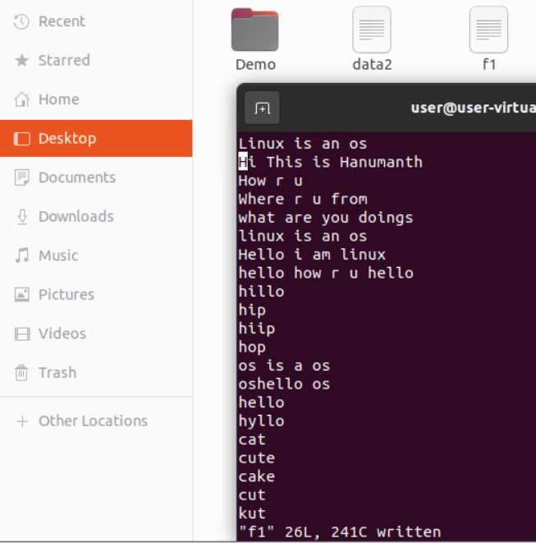

HEAD command:

1.head –n 6 new

It will display 6 lines of new folder.

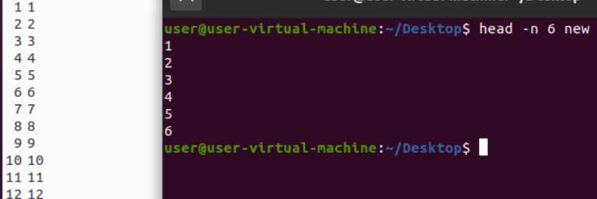

2.head –c 5 new

It will display the five characters in first line

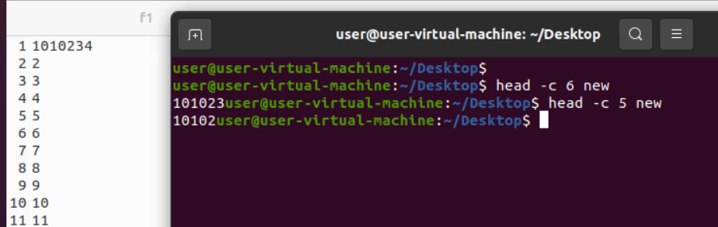

3.head –q new f2

It is used if more than 1 file is given. Because of this command, data from each file is not precedes by its file name.

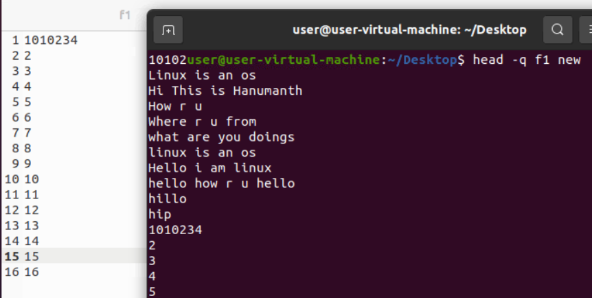

4.head –v f2

By using this option, data from the specified file is always preceded by its file name.

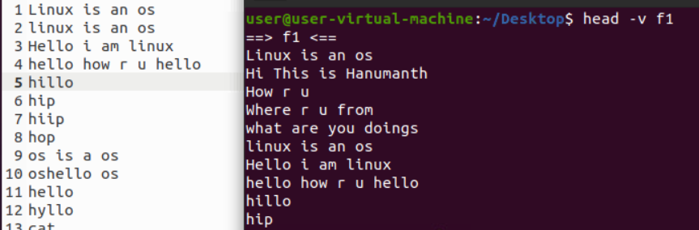

TAIL command:

**1.tail -n 3 f2**

It will display last 3 words.

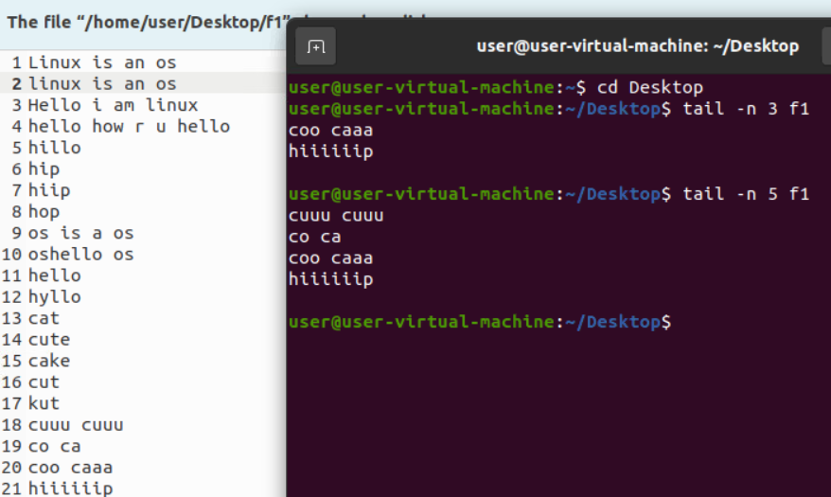

2.tail –c 5 f1

It will display the bytes

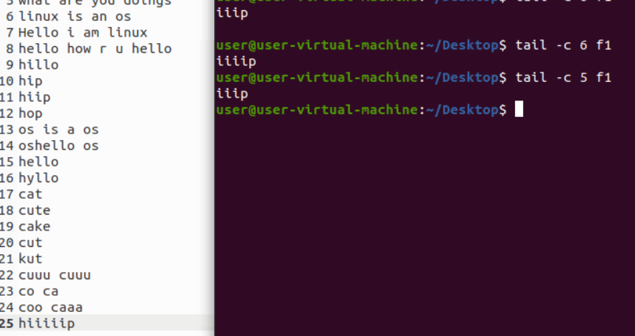

3.tail –v f1

It will display the last 10 words and filename.

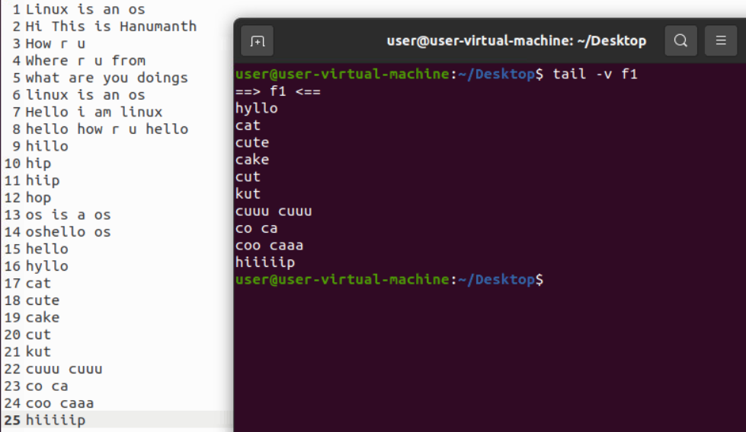

4.tail –version

It will display the version.

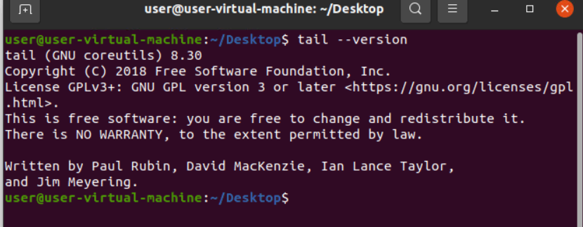

5.tail –q f1

It will display last words in two files.

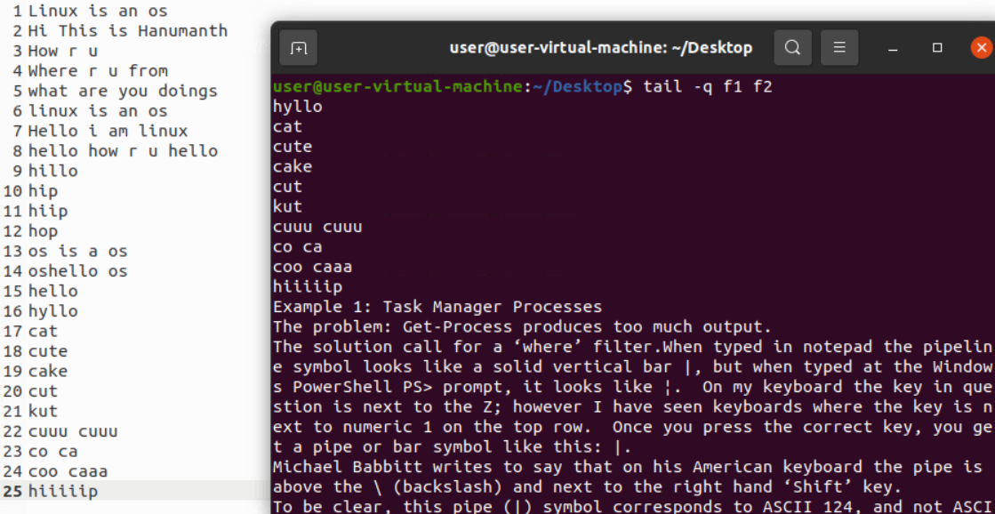

FIND commands:

1.find

It will display all folders present in desktop.

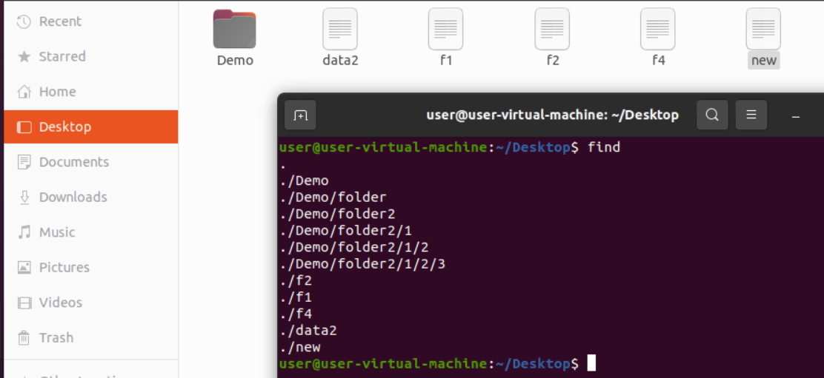

### 2. Find a directory

### The ' type -d' option is used to find a directory. Consider the below command:

### 